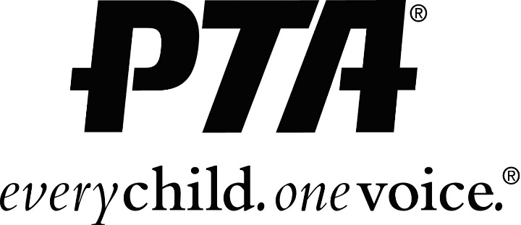

MCVEY PTA WANTS YOU!!!
2021-2022
Dear Parents, Guardians and Staff members,

Looking to connect with your school, volunteer at a PTA event, or maybe even run an event, be an advocate for children or just want to be a member of a great organization? McVey PTA is looking for you! PTA is the largest advocacy organization of ALL. PTA is the reason why school buses are yellow, why cigarettes are no longer advertised on television. East Meadow PTA also helped put the HIPPA law in effect.

The last three years in our district, we had the most members. We hope to continue to lead the way in membership.

PTA gives so much to students. We provide the planners and folders, and sponsor events such as the Wellness Walk, Halloween Howl/Spooky walk, Gingerbread fun, Bingo, School-wide Field Day, Carnival and BBQ, Movie night Under the Stars, just to name a few. We also arrange the boutique and book fairs for our children as well as providing Art and Education (assemblies). Our impact on the school is priceless in creating lifelong memories for our children.

By sending in your PTA membership, you have participated in our first fundraiser of the year.

You will need to be a current member to volunteer at any events!

Our PARENT, TEACHER ASSOCIATION is all about the kids!! Reminders will come in an email when you join. We also have a Facebook page, McVey PTA, East Meadow.

Please join us and send you payment of $10 for a single person, $15 for a double membership and each member is $5 extra!!!
PLEASE MAKE SURE YOU PUT YOUR EMAIL ADDRESS ON THE FORM AS WE ARE PAPERLESS NOW!!! ALL FIELDS MANDATORY!! Cash or checks made payable to McVey PTA. Thank you for your support!
Any questions please contact, Amy Ramnarine (347) 239-0541

2021/22 Membership Form

Member 1 Member 2

Email (must) Email (must)

Cell phone number(preferred)

Child/children’s name and class #

_______Single $10 (one person) _______Double $15 (two people)

